Eclipse Version: 2024-06 (4.32.0) (Build id: 20240606-1231) was used to create the software.
To use the software you need to import the package from a folder on your computer.
To do this, simply launch Eclipse and click the "File" menu at the top left (see Fig.1)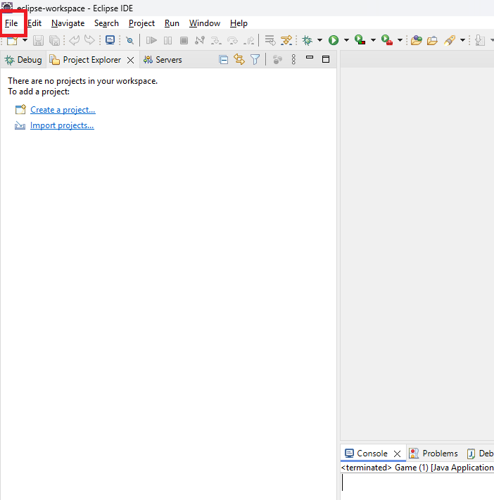
Fig. 1
Then, click on the "Import" item to import the project (see Fig.2).
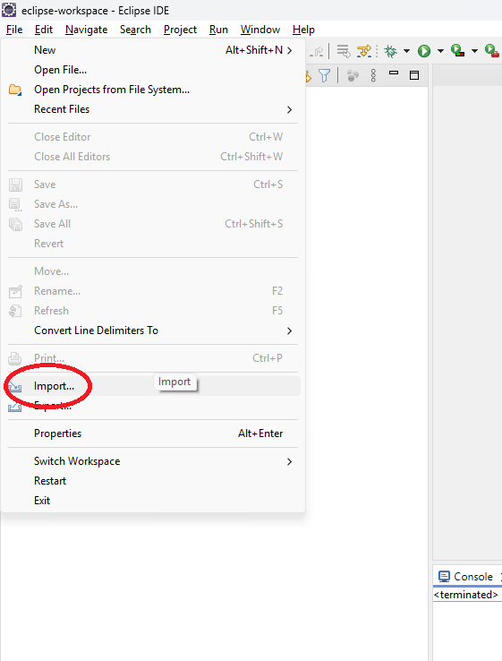
Fig. 2

A project import window will appear, where you need to unzip the "General" entry and select the "Projects from Folder or Archive" sub-item. Then, click the "Next" button (see Fig.3).

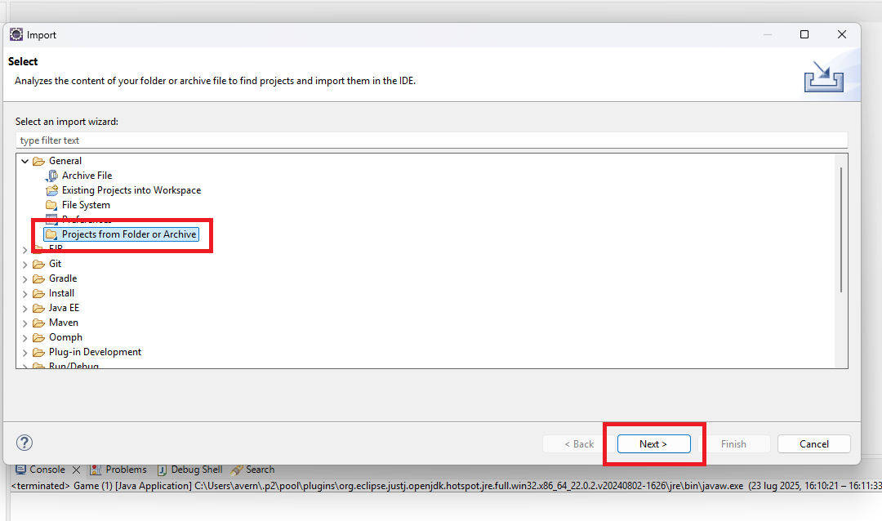
Fig. 3
The "Import Projects from File System or Archive" window will appear. Then, enter the folder where the code is stored in the "Import source" field, or click the "Directory" button to navigate to and select the folder where the code is stored. Finally, click the "Finish" button (see Fig.4).
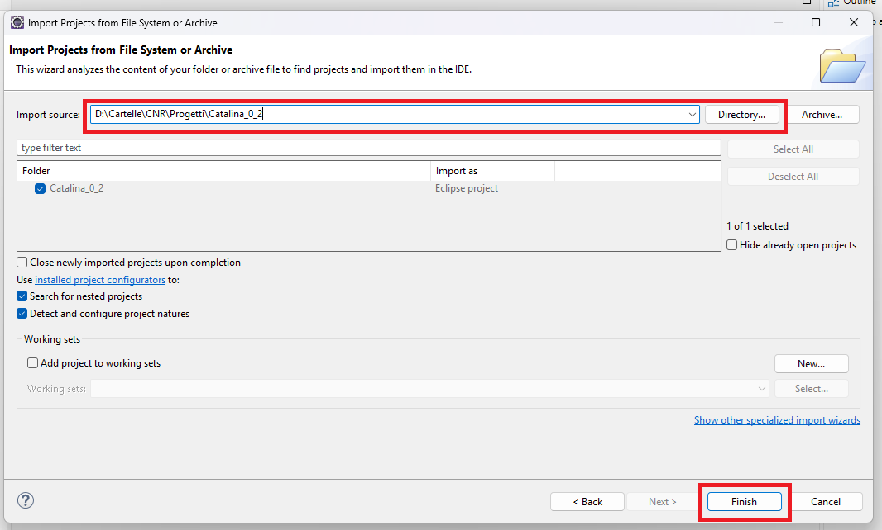
Fig. 4

The project will be imported and the project structure will be displayed in the "Project Explorer" section. All files belonging to the project will also be showed (see Fig.5).
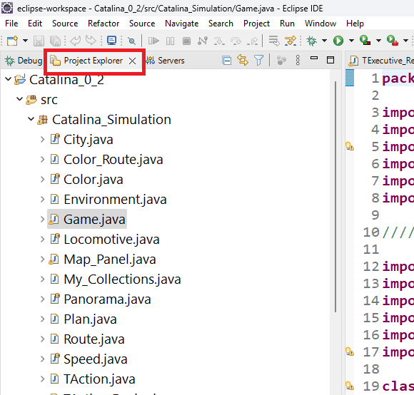
Fig. 5
Double-click the "Game.java" file to display the simulation class code from which to run the entire simulation (see Fig. 6).

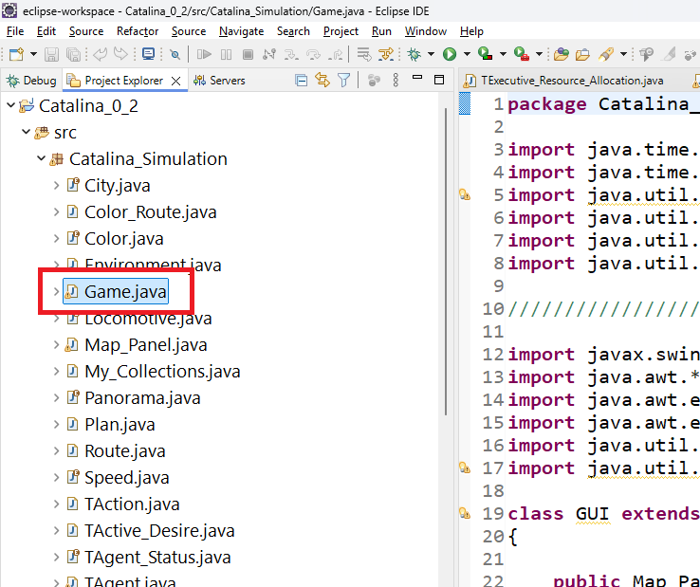
Fig. 6

To run the simulation, simply click on the "Run" menu and then click on the "Run" item (see Fig. 7).
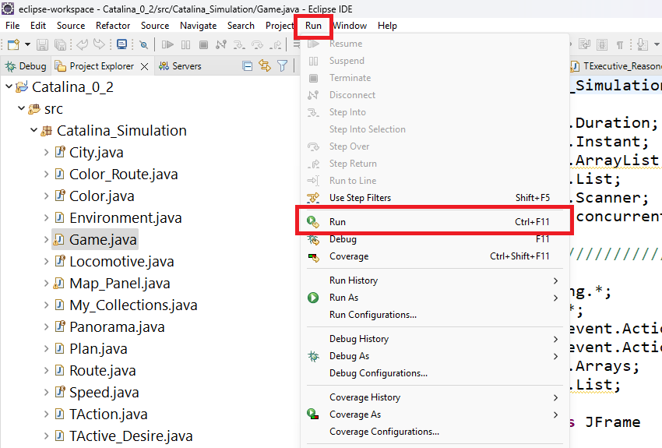
Fig. 7
The simulation will be started with a graphical interface showing the simulation map and a machine representing the autonomous vehicle (see Fig. 8).
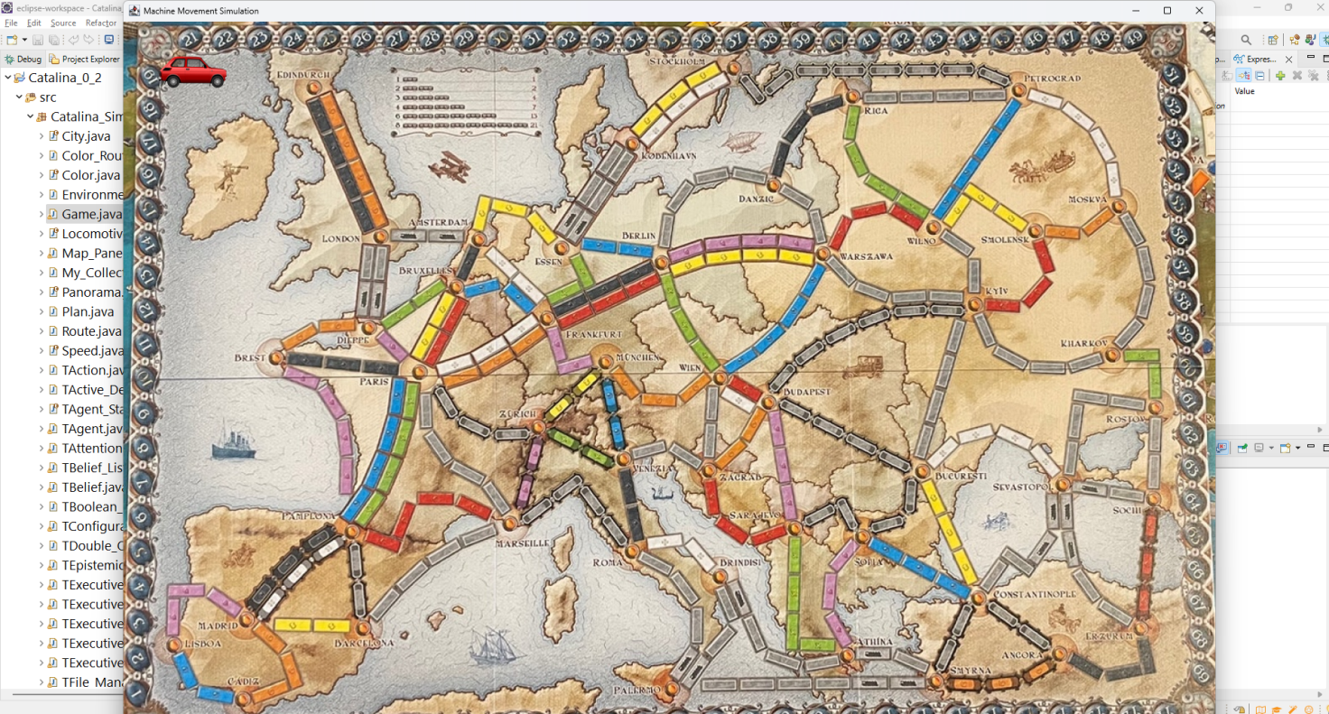
Fig. 8
The simulation has some preset parameters such as:
- The Simulation start date and time: 2024-10-01 16:00
- The City to arrive for Practical Desire 1 is: Paris
- The City to arrive for Practical Desire 2 is: Rome
- The City to arrive for Practical Desire 3 is: Frankfurt
- The City of the precondition to trigger the Practical Desire 2 is: Paris
- The Starting station of the simulation: Lisboa
- The Start time of Finally Operator for Practical Desire 1 is: 2024-10-01 18:00
- The End time of Finally Operator for Practical Desire 1 is: 2024-10-02 06:00
- The Start time of Finally Operator for Practical Desire 2 is: 2024-10-02 10:00
- The End time of Finally Operator for Practical Desire 2 is: 2024-10-02 13:00
- The Start time of Finally Operator for Practical Desire 3 is: 2024-10-02 14:00
- The End time of Finally Operator for Practical Desire 3 is: 2024-10-02 16:00
These parameters can be modified. To try a different simulation configuration, the system will ask you to enter new data. If you don't want to change the default data, simply press "Enter" on your keyboard for each entry you don't want to change. If you want to change the cities, you must enter the names as they appear in the "City.java" file. If you want to change the dates and times, you must write the dates and times in the following format: "yyyy-MM-dd HH:mm" (year-month-day hour:minute), for example, "2025-08-01 14:32".
While the simulation is running, to simulate a camera view, the simulation will ask the user if the AV encounters an obstacle each time it needs to move along its path. If it doesn't encounter an obstacle, the AV continues along the road it has chosen to travel. If it encounters an obstacle, the system first asks what type of obstacle it encounters on the road and then (to simulate the Traffic Control Service) it asks for how long (a simple integer) that road will be blocked by the obstacle.
Good simulation.

